Project Design Phase-II
Data Flow Diagram & User Stories
Date | 27/09/2026
Team ID | SWTID-2026-7148
Project Name | AI Weatherwise API
Maximum Marks | 4 Marks

Data Flow Diagrams:
A Data Flow Diagram (DFD) is a traditional visual representation of the information flows within a system. A neat and clear DFD can depict the right amount of the system requirement graphically. It shows how data enters and leaves the system, what changes the information, and where data is stored.
For the AI WeatherWise API, the DFD represents the flow of user requests through the REST API, JWT authentication, weather data retrieval from the OpenWeather API, AI processing through Gemini AI, storage of application data in MongoDB, and the AI chatbot request and response flow through the existing AI service.
The AI chatbot is implemented as a backend REST API feature. It does not have a separate frontend, new database model, or conversation history storage.
Example: (Simplified)
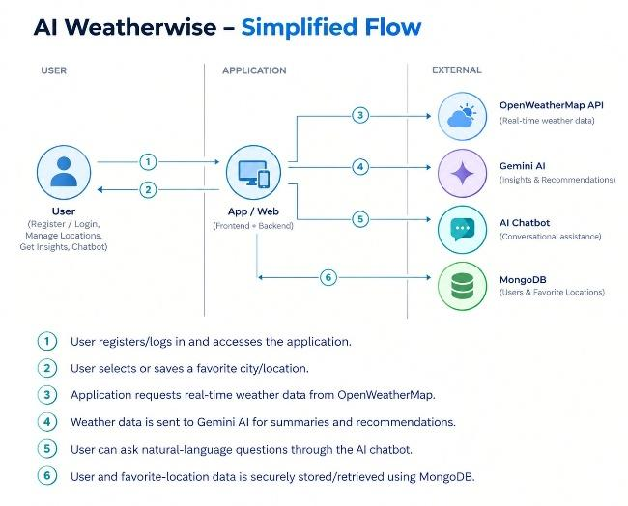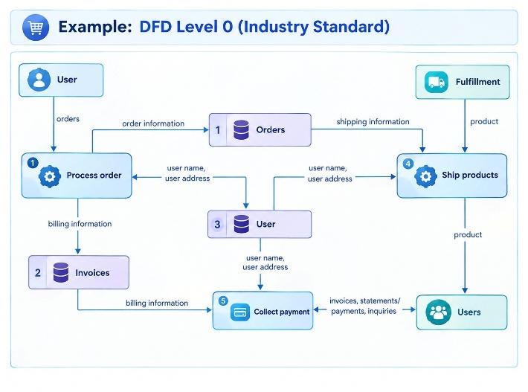

User Stories
Use the below template to list all the user stories for the product.
User Type | Functional Requirement (Epic) | User Story Number | User Story / Task | Acceptance criteria | Priority | Release
User | Registration / Authentication | USN-1 | As a user, I can register for the AI WeatherWise API application using my required credentials. | User account is created successfully. | High | Sprint-1
User  User | Login | USN-2 | As a user, I can log into the application using my credentials. | User is authenticated successfully and receives access to protected API features. | High | Sprint-1
User | Weather Information | USN-3 | As a user, I can request weather information for a location. | Weather information is returned successfully for the requested location. | High | Sprint-1
User | Favorite Locations | USN-4 | As a user, I can save and access my favorite locations. | Favorite locations are stored and can be retrieved for the authenticated user. | Medium | Sprint-1
User | AI Weather Summary | USN-5 | As a user, I can receive an AI-generated summary of weather information. | The system returns an AI-generated weather summary. | High | Sprint-1
User | AI Weather Recommendation | USN-6 | As a user, I can receive AI-generated recommendations based on weather conditions. | The system returns an AI-generated weather recommendation. | High | Sprint-1
User | AI Chatbot | USN-7 | As a user, I can send a weather-related message to the AI chatbot through the REST API. | The API accepts the message and returns an AI-generated reply. | High | Sprint-1
User | AI Chatbot Authentication | USN-8 | As an authenticated user, I can access the AI chatbot using the existing JWT authentication. | Unauthenticated requests cannot access the protected chatbot endpoint. | High | Sprint-1
User | AI Chatbot Error Handling | USN-9 | As a user, I can receive an appropriate response when the chatbot service is unavailable or a valid API key is not configured. | The system provides a fallback response or handles the error appropriately. | Medium | Sprint-1

